Problem Statement: There can be multiple customers, who can place multiple orders on the site. Now a sales person can handle these orders will distribute into multiple sales persons (One order will be assign to one salesperson only). So a sales person can have multiple orders of multiple customers
1. Create Database
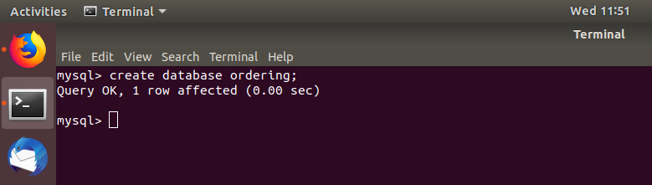

2. Design Schema
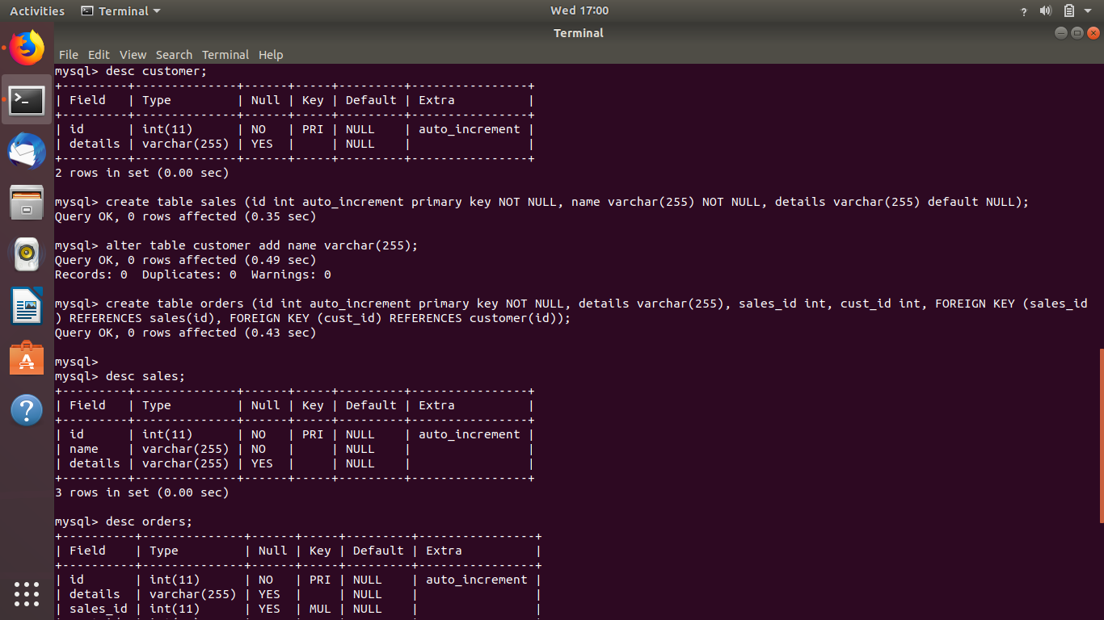
3. Create tables
Same as Question 2 as there is no difference between the questions
4. Insert sample data
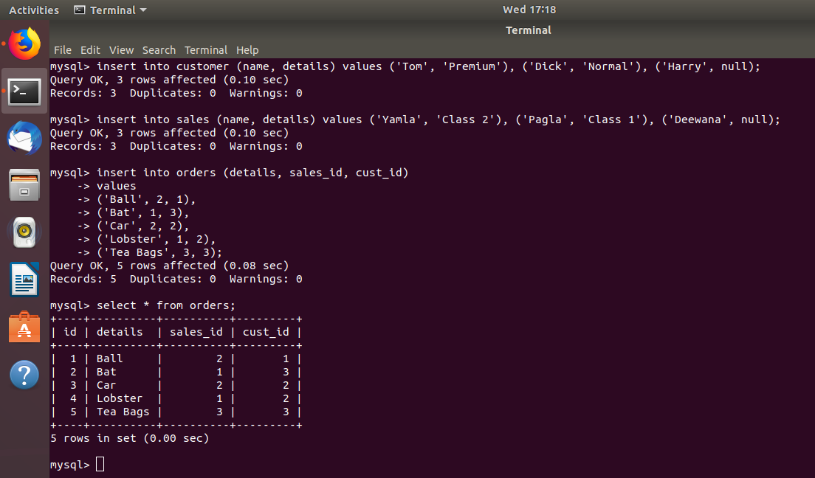

s

5. Find the sales person have multiple orders.
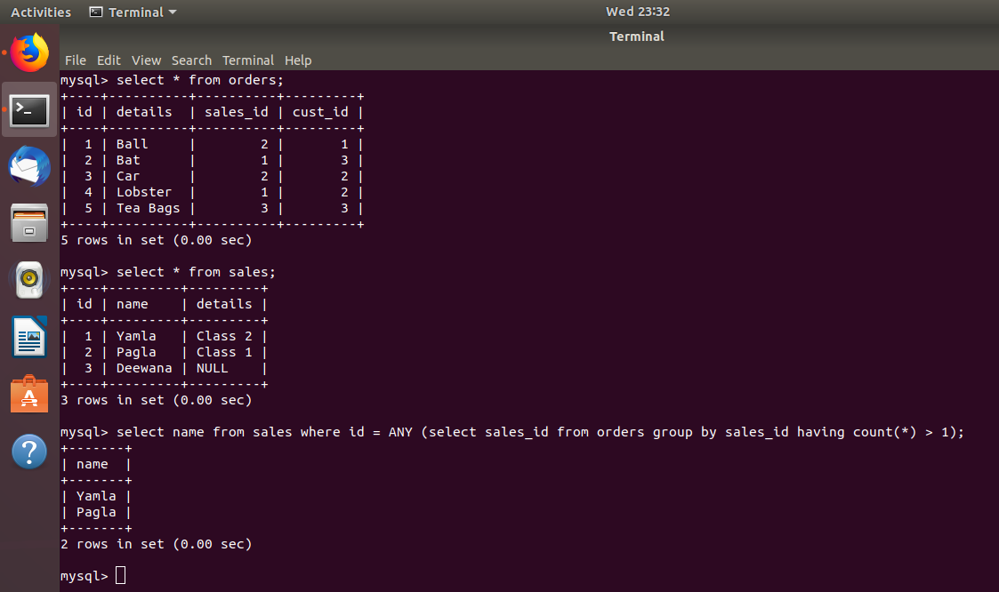
F

6. Find the all sales person details along with order details
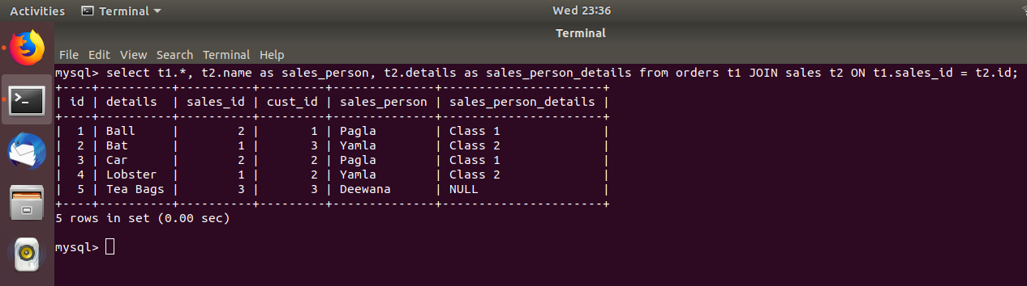

7. Create index
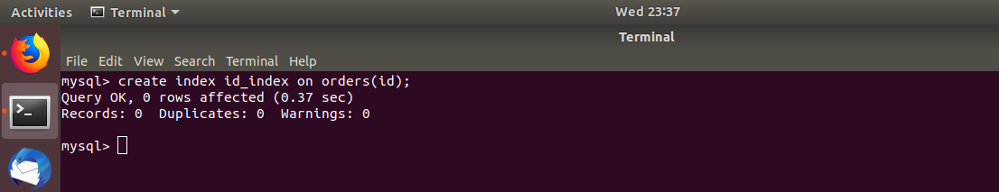

8. How to show index on a table
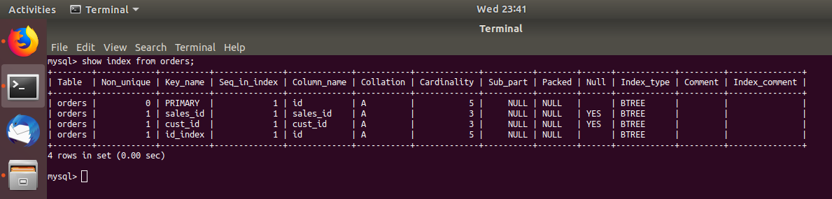

9. Find the order number, sale person name, along with the customer to whom that order belongs to
